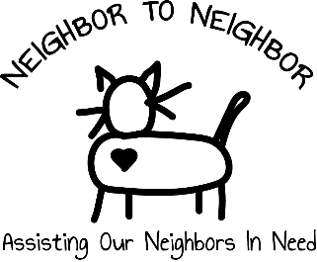

The Neighbor to Neighbor Fund of the Finger Lakes Area Community Endowment (FLACE) offers one- time assistance to individuals & families in crisis. The fund accepts applications on behalf of individual clients from health & social service agency representatives who may submit the application by email or mail. Agency representatives can generally expect a decision within ten working days, and if approved, funds are sent to the agency to distribute to the vendor for payment.

Community members support Neighbor to Neighbor and there is a limited amount of funding available. Our grant limit is $500, although occasionally (or in extraordinary circumstances) we may award larger grants if funds are available. To apply, please complete the form below. Examples of the type of needs the Neighbor to Neighbor Fund may help address include medications & other health-related emergencies, car repair, security deposits, utility payments to prevent shut-off, food, legal services, etc.

The agency representative completing this form will be notified by email of the decision on the application or if there are questions. For consideration, please complete both pages in full. If more space is required, attach an additional page.

Date of Request: _____________________________ Name of Agency: _______________________________

Contact Person: _______________________________ Phone # (with ext.): ___________________________

Agency MAILING Address ___________________________________________________________________

Email: ___________________________________________________________________________________

Agency’s Relationship to individual applicant: ___________________________________________________

Individual Applicant’s Name (Will be kept confidential): ___________________________________________

Individual Applicant’s Address: ______________________________________________________________

City/Town: ______________________________________________ Zip Code ________________________

Description of applicant’s circumstances
________________________________________________________________________________________

________________________________________________________________________________________

________________________________________________________________________________________

________________________________________________________________________________________

________________________________________________________________________________________

What is funding requested for and why can the applicant not pay for this? ________________________________________________________________________________________

________________________________________________________________________________________

________________________________________________________________________________________

________________________________________________________________________________________

________________________________________________________________________________________

Total Cost: $___________________ Amount secured from other sources: $____________________

Amount sought from Neighbor-to-Neighbor Fund: $______________

How is your agency working with this person/family to prevent further crises?

______________________________________________________________________________________

______________________________________________________________________________________

______________________________________________________________________________________

You will be notified of the decision on your application by email within two weeks.

If you have questions, please email information@neighbortoneighborfund.org

Email application to – request@neighbortoneighborfund.org

Or mail to : Neighbor to Neighbor, PO Box 756, Canandaigua, NY 14424

This area for office use only -
Date Received: ______________________________ Approved: □ YES □ NO

Date Response sent to Agency: _________________ Neighbor to Neighbor Representative: _______________________

Type of Funding: □ Food □ Health/Medical □ Housing □ Legal □ Utilities □ Other

NOTES:

